Procedure to Run Mini Project

(Driving School Management System)

* Pulin Shah (A3 – 1611045)
* Kaushal Yadav (A3 -1611054)
* Parth Shah (A3 – 1611044)

Pre-requisites:- XAMPP

To install XAMPP:-

1). Download and install latest version of XAMPP from : <https://www.apachefriends.org/download.html>

2). From the XAMPP Control Panel, start the Apache Server & MySQL server.

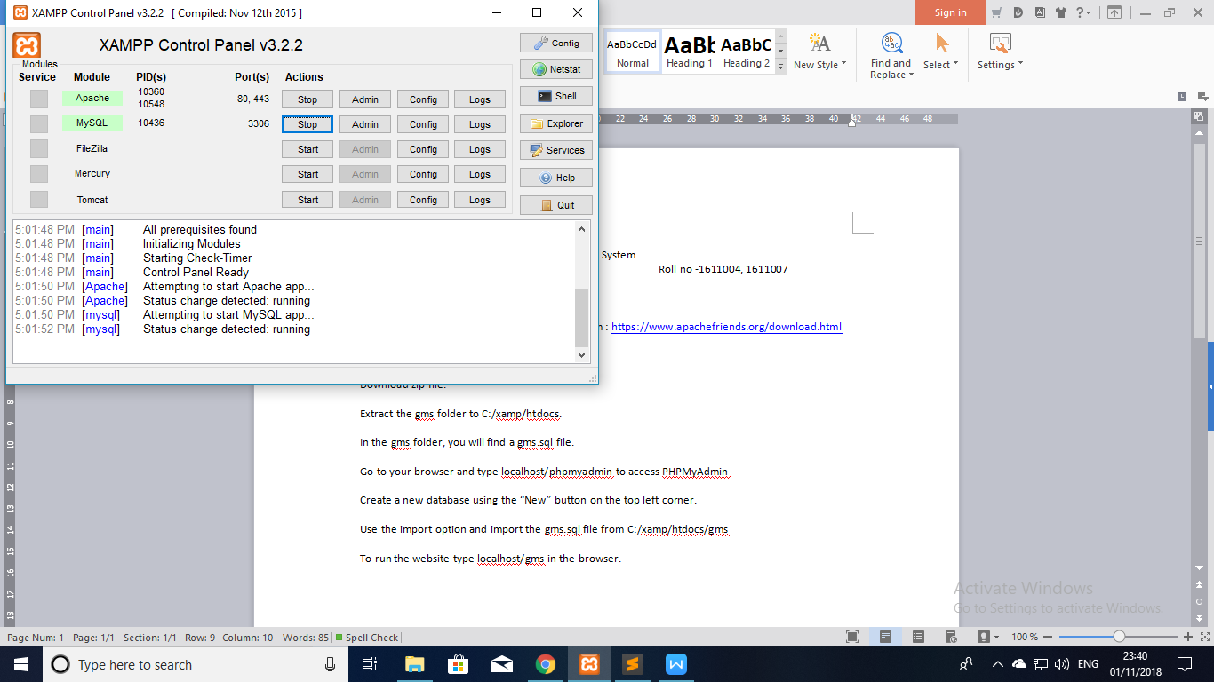

3). Download the ZIP file provided along with this manual. Extract it. 2 folders will appear, copy the DSMS folder into the “htdocs” folder. This folder will be found where you chose to install XAMPP, usually in C drive, inside XAMPP folder.

4). To set up the database, open your browser, go to “localhost/phpMyAdmin”,

Create a database named “drivingschool” (Note:- The name is case sensitive)

5). Once database is created, select the import option and there upload the SQL file inside the “Database” folder found in the file extracted.

6). Once done the tables will appear as such

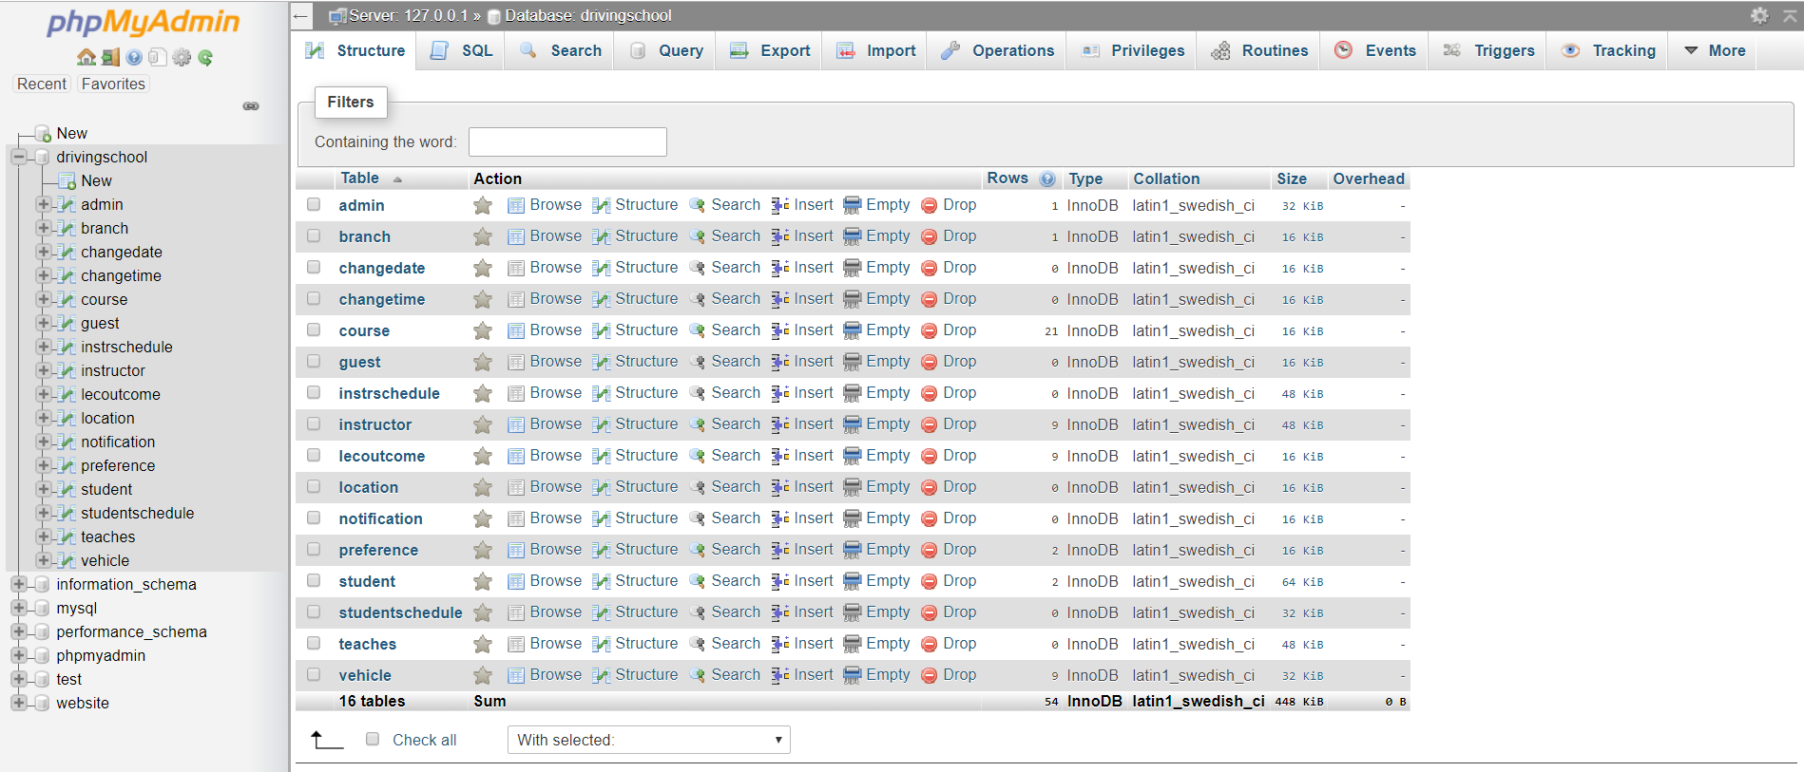

7). Now it is time to add the configuration files. Inside C: drive, open XAMPP folder, open folder “php”, and replace the “php.ini” file from the Configuration folder into the “php” folder.

Do the same for “sendmail.ini” and replace it in “sendmail” folder inside XAMPP folder.

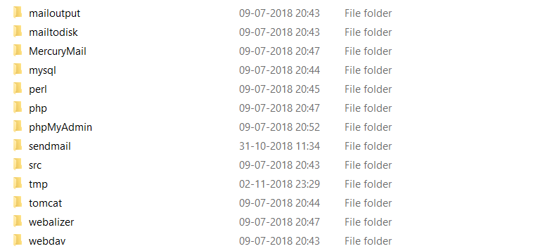

8). Now you are ready to explore the site.

Just type “localhost/DSMS/index.html” to go to the home page.

Website opens at the home page. The description of the driving school can be added & is intentionally left to the default blank text.

You can login as an Admin, Guest, Instructor or Student.

Username and passwords are given for Admins & Instructors below as a user who isn’t an admin cannot create an Instructor account.

You can sign up as a guest, and will have to follow registration steps.

Note there is authentication on the basis of emails, so you must provide a valid email address, and there is a possibility mails from our side might be in your spam folder.

Credentials for Admin

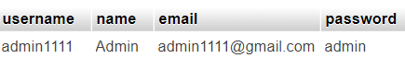

Credentials for Instructors in the system

